RESUME

Name of Teaching Staff | Dr. Supriya Suresh Raskar |  |  | 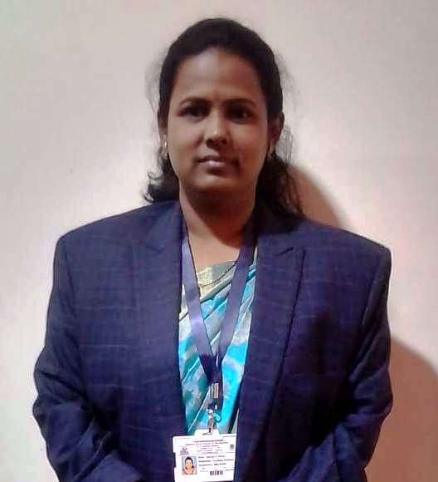
Institute Name | PDEA`S Mahatma Phule Institute of Management and Computer Studies, Hadapsar, Pune.
Designation | Assistant Professor
Department | MBA
Area of Specialization | Human Resource Management
Date of Joining the  Institute | 01/08/2018
Qualifications with Class/Grade | UG  (B.C.A.) | Distinction | PG  (M.B.A.) | Distinction | M.Phil. | “O” Grade | Ph.D.
Total Experience in  Years | Teaching | 3 Yrs | Industry | 2 Yrs
Paper Published | National | 04 | International | 02
Books Published | -

